Recommendation on Ticket Price & Facilities Adjustments

for Big Mountain Resort

**Statement of Issues**

1. **We did not have a data-driven price point.** Previously, our resort has simply pegged our ticket price to the average price of resorts in our market segment without analyzing potential for increases.
2. **We did not understand the ROI of our facilities.** We did not know which of our facilities are driving ticket sales and which are not earning back their own operating costs.
3. **We must cover the $1.5mil operating cost increase from the new lift.** We built the lift without understanding the specific ROI, and are at risk of running at a loss without adjustments to prices or facilities.

With these issues in mind, our task can be summarized as follows:

| *We will model data of competing resorts in order to recommend a new ticket price and adjustments to specific facilities available at our resort that will increase revenue by at least $1.5mil/year. The new price & changes for next season must be implemented before tickets for next season go on sale.* |
| --- |

**Conclusion Overview**

Our team has developed a mathematical model that defines the relationship between the 8 most-valued resort features and ticket prices of all resorts in our market share. Our model concludes that **our current ticket price vastly under-values our offerings. The market supports an increase in our adult weekend ticket price of about $14, from $81 per adult weekend ticket to $95 (+-$5).**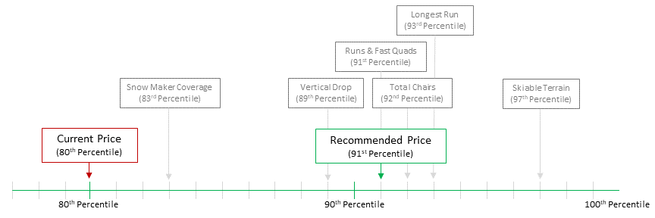

***Fig 1:*** *Our current price point lags behind the value of our*

*offerings compared to other resorts in our market segment.*

With the expected annual visitor count to be 350,000 and the average number of daily tickets per visitor to be 5, **this price increase could increase annual revenue by about $24.5mil**, well above our target threshold.

Regarding facility utilization, we have identified **two proposals for further exploration:**

1. **Closing our least-used run would reduce operating costs while having no measurable impact on revenue.** Our model indicates that closing one run would have no effect, closing two would reduce revenue by about $0.7mil, and closing between 3-5 runs would have an impact of about $1.2mil total.
2. **Extending our longest run by 0.2 miles, accompanied by a 4-acre increase in snow production, could support a further price increase that could additionally increase revenue by over $3mil.**

**Methodology and Data**

The core of our model was the data on our market segment supplied to us by Alesha Eisen, Database Manager. We removed data for resorts with no listed ticket price, and added data pertaining to local population and area.

At this point, we used simple graphs to compare each of these features to the resorts’ ticket prices, looking for potential relationships. We found that high vertical drops, the number of fast quad lifts, and the total number of lifts & runs had potentially the greatest impact on the chargeable ticket price.

To more closely define & explore these relationships, we standardized our data and began testing linear models, asking our models to predict a ticket price given a set of resort features. In order to test the performance of our models, we trained them on a subset of the existing data (the “training data”), then used them to predict the prices in the remainder of the data (the “test data”). We performed this process multiple times, changing which subset of our data was used as the “test data” each time to make sure our model wasn’t overly-specific to any particular subset of the data.

We found that removing some apparently irrelevant features from the data by automatically calculating the 8 most relevant features and then using only those features in our training. This allowed our linear model to achieve a maximum R2 score of about 0.67.

We then explored using a random forest model, which, after tweaking some hyperparameters, produced more accurate results of about R2 = 0.71. It is this model that suggested the $95 price point, with an accuracy of about +-$5.

At this point, we can clearly show the relative importance of various resort features with regards to setting the price point:

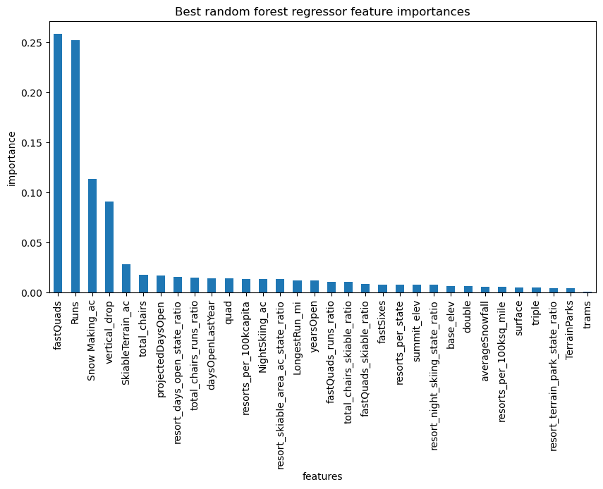

We can also re-run the models with smaller subsets of the data, increasing the amount of data available each time, to see if more data would produce better/more accurate results. This shows us that the accuracy of the predictions plateaus at a point well before the amount of data we currently have, so collecting more data is probably not necessary to improve accuracy.

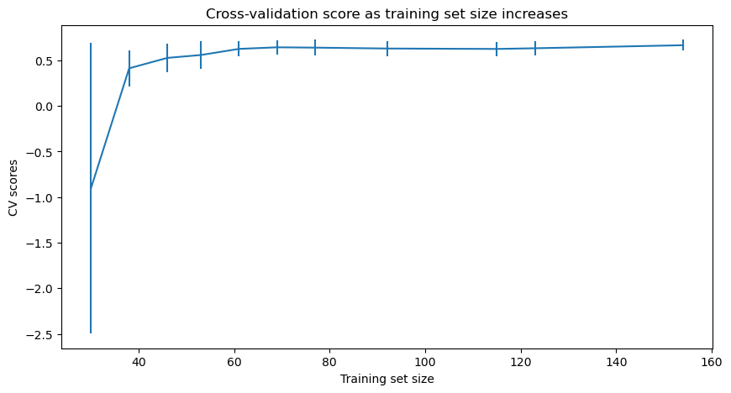

All of this tells us, with a high degree of certainty, that Big Mountain’s price point lags far behind the prices that consumers are willing to pay for similar facilities at other resorts.

**Future Scope of Work**

We recommend taking the following steps to ensure maximum ROI for Big Mountain’s facilities moving forward:

1. Perform an analysis of the operating costs of each of Big Mountain’s facilities. This would allow our model to not only project changes to revenue, but also to profit.
2. Gather and standardize data on the motivations & desires of our customers. This insight would give us a clearer idea of the specific price point to select within the range suggested by the model, and also allow us to more effectively redistribute resources recovered by the suggested reductions in operating costs.
3. Develop a specific plan for testing the run closures suggested by the model. We recommend closing one run per year for up to four years, making sure to check each time that the changes to revenue match the model’s predictions.
4. Scale the model we’ve created here into an application that Big Mountain’s executives and directors can use to analyze potential future courses of action. We will maintain and update the underlying model on a yearly basis.